The Anti-War Movement
United States History, Documents-Based Question
By Nicholas Gugliemelli

Total Time – 1 Hour, 30 Minutes
Suggested Reading Time: 15 Minutes
Suggested Writing Time: 45 Minutes

Directions: The question is based on the seven accompanying documents which have been edited for this exercise.

In your response you must do the following:
- Develop a historically defensible thesis that directly addresses the question in all parts.
- Support the thesis with evidence from at least six of the seven documents.
- For at least three of the documents explain the significance, purpose, context, or target audience.
- Use at least one additional piece of historical evidence outside of the provided documents to support your thesis.
- Place your argument in the context of history by describing how other events are related.
- Extend the argument by connecting it to either a different historical period or theme in United States history which is not part of the assigned topic.

1. Explain the reasons why an anti-war movement developed in the United States in response to the Mexican American War.

Document 1
Source: Charles Sumner, “The True Grandeur of Nations” (speech, Boston, July 4, 1845).

The subject will raise us to the contemplation of things that are not temporary or local in their character; but which belong to all ages and all countries; which are as lofty as Truth, as universal as Humanity. But it derives a peculiar interest, at this moment, from transactions in which our country has become involved. On the one side, by an act of unjust legislation, extending our power over Texas, we have endangered Peace with Mexico; while, on the other by a presumptuous assertion of a disputed claim to a worthless territory beyond the Rocky Mountains, we have kindled anew on the hearth of our Mother Country, the smothered fires of hostile strife. Mexico and England both aver the determination to vindicate what is called the national honor; and dread the arbitrament of war is calmly contemplated by our Government, provided it cannot obtain what is called an honorable peace.

Full text available online at: https://library.uta.edu/usmexicowar/item?content_id=220&format_id=6&ofst=0&ni=1,846

Document 2
Source: Preston King, “The Wilmot Proviso: Bill and Explanation” January 1847.

Every inch of Texas was yielded to slavery. I know that it was reluctantly yielded to the possession of slavery by many who supposed the acquisition of Texas might be hazarded by any dissension about the terms so strenuously insisted upon by the representatives of the slave States; but, with Texas, the extension of slavery, it was supposed, would stop. It was hoped the South would not desire to carry it where it does not now exist. Is this so? The two millions are distinctly, urgently, and repeatedly recommended by the President to be appropriated. There is no other purpose for which this appropriation can be wanted except in connexion with a cession of territory by Mexico. Mexico already owes us unpaid indemnities for acknowledged and adjudicated spoliations on our commerce. I repeat, we must have territory from Mexico; and there can be no harm or impropriety in stating what circumstances, and every action of our Government, proclaim to the world as clearly and as unerringly as words could do.

Full text available online at: https://library.uta.edu/usmexicowar/item?content_id=1412&format_id=6&ofst=0&ni=2,719

Document 3
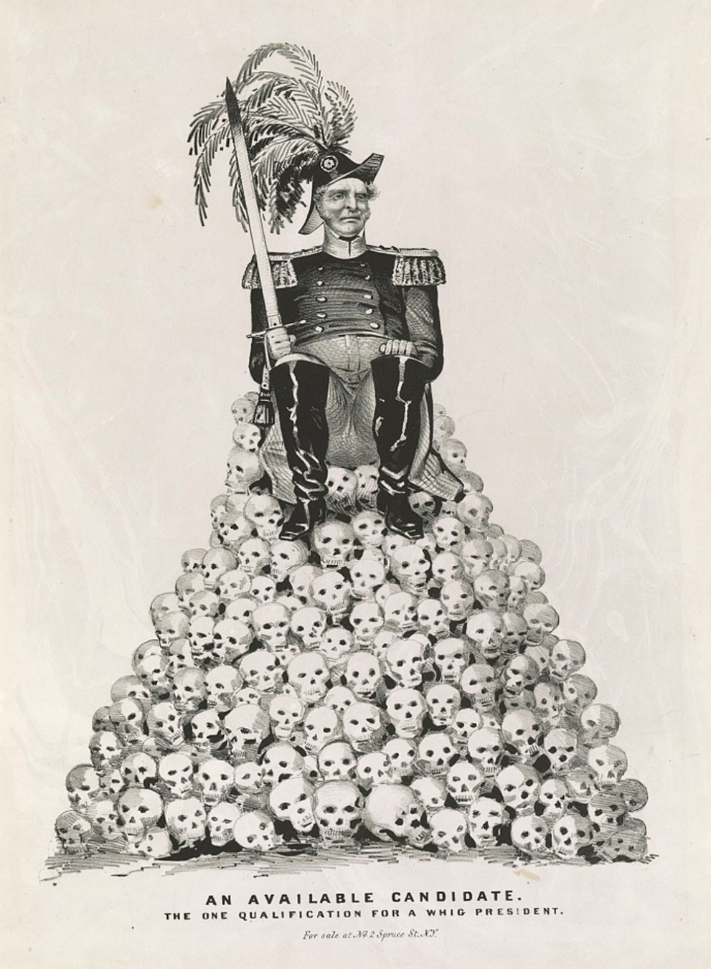
Source: Nathaniel Currier, “An Available Candidate: The One Qualification for a Whig President”, 1848.

Image available online at: https://www.loc.gov/pictures/item/90708859/

Document 4
Source: Edited by Frederick Douglass, The North Star Editorial, “The War with Mexico”, January 21, 1848.

We have no preference for parties, regarding this slaveholding crusade. The one is as bad as the other. The friends of peace have nothing to hope from either. The Democrats claim the credit of commencing, and the Whigs monopolize the glory of voting supplies and carrying on the war; branding the war as dishonorably commenced, yet boldly persisting in pressing it on. If we have any preference of two such parties, that preference inclines to the one whose practice, though wicked, most accords with its professions. We know where to find the so called Democrats. They are the accustomed panderers to slaveholders: nothing is either too mean, too dirty, or infamous for them, when commanded by the merciless man stealers of our country. No one expects any thing honorable or decent from that party, touching human rights. They annexed Texas under the plea of extending the area of freedom. They elected James K. Polk, the slaveholder, as the friend of freedom; and they have backed him up in his Presidential falsehoods. They have used their utmost endeavors to crush the right of speech, abridge the right of petition, and to perpetuate the enslavement of the colored people of this country. But we do not intend to go into any examination of parties just now.

Full text available online at: https://www.loc.gov/item/sn84026365/1848-01-21/ed-1/

Document 5
Source: W. P. Tilden, “All War Forbidden by Christianity”, (Sermon, Dover, November 25, 1847).

But even if war in any case could be shown clearly to be defensive, it would not make it Christian, because the subject of Christ’s kingdom cannot fight. If this be true, and has not Christ said it? It is obvious that there never was and never can be a Christian war.

We often hear the present war upon Mexico spoken of as unchristian; as though, if it were not aggressive it would be Christian. I have no faith that opposition to war will ever accomplish much in its removal from the earth. It is no repudiation of war itself, but only of this war, and even this with all its atrocities, becomes Christian with this view to all who think it is, on the whole, necessary under the circumstances.

If the servants of Jesus cannot fight, then a war to be Christian, must be carried on without fighting. Christian weapons are not carnal but spiritual – the weapons of truth and love. To speak of a “holy war,” seems to me as much a contradiction in terms as it would be to speak of righteous sin, or forgiving vengeance.

Full text available online at: https://library.uta.edu/usmexicowar/item?content_id=1733&topic_id=31&format_id=11&ofst=15&ni=16

Document 6
Source: Abraham Lincoln, “Lincoln’s Spot Resolution”, 1847.
Whereas the President of the United States, in his message of May 11th. 1846, has declared that “The Mexican Government not only refused to receive him, or listen to his propositions, but, after a long continued series of menaces, HAS at last invaded our territory and shed the blood of our fellow-citizens on our own soil:”
And again, in his message of December 8, 1846 that “We had ample cause of war against Mexico, long before the breaking out of hostilities. But even then we forbore to take redress into our own hands, until Mexico herself became the aggressor by invading our soil in hostile array, and shedding the blood of our citizens:”
And yet again, in his message of December 7, 1847, that “the Mexican Government refused even to hear the terms of adjustment which he [our minister of peace] was authorized to propose; and finally, under wholly unjustifiable pretexts, involved the two countries in war, by invading the territory of the State of Texas, striking the first blow, and shedding the blood of our citizens on our own soil”
And whereas this House is desirous to obtain a full knowledge of all the facts which go to establish whether the particular spot of soil on which the blood of our citizens was so shed was or was not our own soil, at that time.
Full text available online at: https://www.loc.gov/item/mal0007000/

Document 7
Source: George Putnam, “God and Our Country”, (Sermon, Roxbury, April 8, 1847).

What ground shall we take? The are two ultra methods of settling this question, - two forms of ultraism up on the subject. One is that which excludes moral test and Christian considerations entirely from a man’s view of public and national affairs. This is the doctrine that leads men to put forth and repeat, in word or dead, such infamous maxims as these: - “All is fair in politics”; “Take any advantage you can get over other nations”; “Do your worst in war, and cheat your best in diplomacy”; and most familiarly “Our country, right or wrong.”

The other and opposite kind of ultraism is that which expresses itself in such language as this: - “No union with slaveholders”; “We will not be parties to a constitutional compact which recognizes and sustains a great iniquity”; “The country which wages an unnecessary or unjust war (and many will say that all wars are unjust and unnecessary), that is not our country. We are Christians, and will not own it. Let us separate. Let us dissolve the Union. Let us form a new and smaller one, or else live in righteousness and peace without one.”

Full text available online at: https://library.uta.edu/usmexicowar/item?content_id=457&topic_id=30&format_id=11&ofst=0&ni=1

